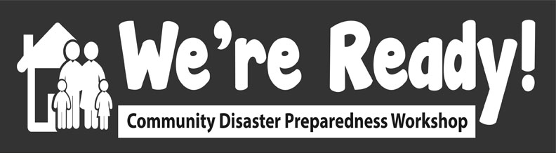

Wrap-up
We’re Ready!
2:50 - 3:00 PM

We’ve come to the end of the workshop. There was a lot of learning and laughter today.

In Chat Storm style, we’d like you to type 1 word or a short sentence in the chat to describe your main take-away from today’s We’re Ready! Train-the-Trainer workshop. So, how this will work is that you’ll have 10 seconds to think about and type in your response. After the 10 second pause, I’ll count to 3 and everyone will press ENTER together. Let’s start the pause. [PAUSE for 10 seconds] . OK, 1...2…3...go!

[FACILITATOR READS OUR RESPONSES]

Thanks for your responses and for your participation today in this online train-the-trainer We’re Ready! workshop. A certificate of completion will be emailed to you shortly.

We’re Ready! is under a Creative Commons license. Today’s workshop was developed by volunteers and provided for free through the Tamarack Institute. In return, we ask you to pay it forward and run a session in your own community by September 2021. This could involve piloting just one of the 30 minute activities with your family or friends; or you could carry out several activities with members of your neighbourhood, your workmates or whomever. Please send the results of the pre- and post-workshop surveys as well as the Organizer Feedback Survey to the main facilitator

An email will be sent to you with members of the Team’s contact information if you have any questions about setting up your own We’re Ready! Workshop or wish to provide any additional feedback. This email will also have the link to the Organizer Feedback Survey from the We’re Ready! website (www.wereready.org), as well as more detail about the Creative Commons license. The Organizer Feedback Survey is to be completed by you after you complete your own workshop. This will help us to gather feedback about what worked and what did not, and how we can further improve the Train-the-Trainer version of We’re Ready!
Based on what we observed at this workshop, we will be making some adjustments to the Instructional Plans and the revised versions will be uploaded by mid-June under the Tools tab.

Thank you again for your time and interest in taking part today. We wish you all the best in running your own workshops and look forward to hearing how it went. Now I will pass it off to the Tamarack Institute.

