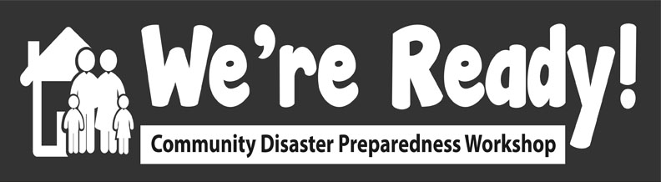

Implementing
‘We’re Ready’ Worksheet
in Your Community

This worksheet is designed to capture the strategies you have identified for implementing ‘We’re Ready’ in your community.

As the train-the-trainer workshop progresses, capture what has worked well, what has not worked well and your ideas for effectively delivering the ‘We’re Ready’ training in your community.

Activity # | What worked well? | What did not work well? | Ideas for delivering my ‘We’re Ready’ workshop
1
2
3
4
5
6
7
8
9

Notes:

