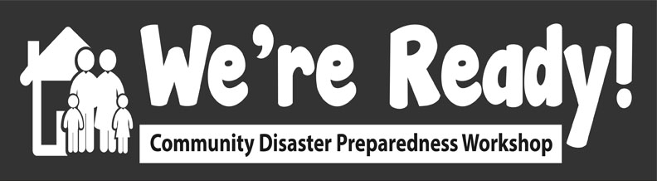

Door Slammers for Community-Level Disaster Preparedness

- This is creating liability!
  - Liability comes from creating danger. Because we know that people will take on these tasks anyway during a disaster, we reduce liability by providing some training.
- This is taking on the job of the Fire Department / EMS / etc!
  - In an emergency, bystanders provide the majority of medical transport, initial search and rescue, and first aid. This reduces the demands on the First Responders and allows them to prioritize people who can’t help themselves.
- This is encouraging looting!
  - Looting is very rare in emergency situations. Generally, disasters are characterized by great social solidarity, generosity and self-sacrifice. The 'therapeutic community' is common: people have a greater tendency to help each other than in normal times.
- People will be too busy panicking!
  - Most people behave rationally in disaster. While panic is not to be ruled out entirely, it is of such limited importance that some leading disaster sociologists regard it as insignificant or unlikely. When it is possible, people make good decisions even in the most stressful situations. This training gives people more good options to take. People only panic when they are unable to carry out their decisions to take protective action.
- People will just leave the area
  - Usually there is a "convergence reaction" and the area fills up with people. Few of the survivors will leave and even obligatory evacuations will be short-lived.
- People won’t respond, they’re the victims!
  - Survivors rapidly get to work on the clear-up. Activism is much more common than fatalism (this is the so-called "therapeutic community"). In the worst possible cases only 15-30 per cent of victims show passive and dazed reactions.

See: Alexander, D.E. 2007. Misconception as a barrier to teaching about disasters. Prehospital and Disaster Medicine 22(2): 95-103. DOI: 10.1017/S1049023X00004441

