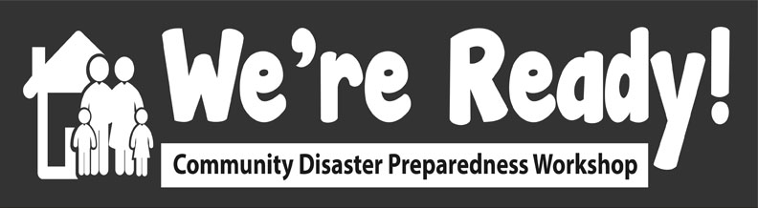

Activity 8: Building Momentum
Session Title: Building Momentum

Date/Time: May 27 2:10 - 2:40 pm MT (30 min.)

Presenter:

Description:

- To plan for building momentum to Create a Community Disaster Plan that can carry forward energy and tools created in this workshop

Learning objectives:

- To realize that long-term success will require ongoing effort
- Provide opportunities to think about what you can do to continue increasing preparedness
- To identify potential leaders and volunteer assistants
- To develop responses to potential barriers to building momentum.

Instructional techniques:

- Each Group Facilitator puts their Jamboard link into Zoom Group chat
- In the Breakout Groups, participants write the answers to these questions first on their own for about 7 minutes, then discuss with group for about 7 minutes.
- After about 15 minutes, return to main group to discuss potential barriers.

Speaking points:

In this activity, you will create a plan for building momentum to Create a Community Disaster Plan that can carry forward energy and tools created in this workshop
  - Disaster Plans are community documents and processes (a ‘Living Document’ that needs to continuously be revised) Note: Ideally, this will be a theme throughout the day.
  - A successful Community Disaster Team includes dedicated volunteers, regular meetings, ongoing learning, etc.

The learning objectives are

- To realize that long-term success will require ongoing effort
- Provide opportunities to think about what you can do to continue increasing preparedness
- To identify potential leaders and volunteer assistants
- To develop responses to potential barriers to building momentum.

Resources & materials:
- Jamboard
- Implementing We’re Ready! in My Community worksheet
- Political Challenges in Disaster Preparedness worksheet (from Reflections on Training Activity X)
- Door-Slammers handout

Schedule:
- Instructions: 5 min.
- Do activity: 15 min.
- Discussion: 10 min. (on barriers)

After the instructions are explained, you will join your Breakout Group, your Group Facilitator will type into the chat the Jamboard link which you will click on and open on your own computer. Using Jamboard, in the Breakout Groups, write your answers to a series of questions (2 Jamboard pages per group) first on your own for about 5 minutes, then discuss with group for about 10 minutes. The questions are the following [MAIN FACILITATOR COPY AND PASTE INTO CHAT:

- How can you apply what you learned today in your community?
- Is there an opportunity to build an “Emergency Preparedness Team” to continue thinking about preparedness in your community?
- Who would you need to involve or contact to be more prepared?
- What resources would you need to continue emergency preparation?

OPTIONAL QUESTIONS:
- How can you translate what you learned today in your household?
- How can you translate what you learned today in your workplace?

Again, if you see that someone else has already created a note of what you are going to say, type something different.

  - In the group discussion, go through each question. Each participant briefly shares ONE response to that question (not more than one point to ensure everyone has a turn - if do not want to share a point from a question then can pass).
  - This is also a good time to jot down ideas in your Implementing We’re Ready! in My Community worksheet of how you would implement this activity in your community.
- After about 15 minutes, return to the Main Room

Let’s now discuss some potential barriers to community-level and community-driven initiatives for emergency preparedness. There are some common door-slammers which are provided on the Google Document/Handout. As we review each of these, think about your responses in the Political Challenges in Disaster Preparedness worksheet (from Reflections on Training Activity X) as well as the Disaster Myths document sent to you. Feel free to share any ideas for how to overcome these barriers as we review them.

Assessment plan:

- Ideas developed for translating/adapting workshop to own community (in Jamboard but also Implementing We’re Ready! in My Community worksheet)?
- Opportunities for a team identified?
- Leaders and/or volunteers identified?
- Resources identified?
- Responses to barriers identified?

Estimated duration of activity:

- 30 minutes

Instructor (I) and participant (P) resources/materials:

- I & P - Jamboard
- P - Implementing We’re Ready! in My Community worksheet
- P - Political Challenges in Disaster Preparedness worksheet (from Reflections on Training Activity X)
- P - Door-Slammers handout
- P - Disaster Myths handout

Volunteers required (# and specific expertise?):

- 1-2 primary facilitators
- 1 Breakout Group facilitator

Facilities required:
- Zoom

Additional notes:

