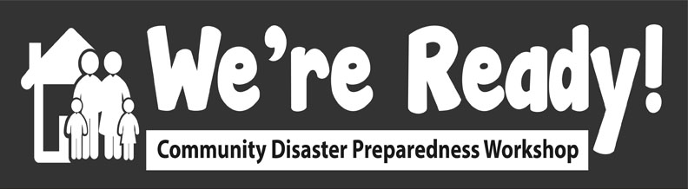
Activity 7: Debrief Exercise/Identify Community Plan Revisions
Session Title: Debrief about Simulation and Identify Community Plan Revisions

Date/Time: May 27 1:40 - 2:10 MST (30 minutes)

Presenter:

Description of learning activity:

Debrief about Simulation and Identify Community Plan Revisions
- Debrief about Mock Disaster Simulation experience

- Identify Community Plan Revisions
  - Based on discussion in #1 above, identify what revisions need to be made to Community Plans (do not need to make those revisions in this activity, just identify)
  - Use language that puts onus on community to keep the community emergency plan going and develop it further

Learning objectives:

- To identify practical lessons learned during the Simulation
- To identify ways to improve the Community Disaster Plans

Instructional techniques:

- Each Group Facilitator will have own Jamboard link (each Group Facilitator has own Jamboard) to put into Chat once in Group
- After instructions, participants go into their assigned breakout groups and complete the activity
- After group work, all return to Main Room. Group Presenter for each group shares ONE highlight/observation from their group
- Participants write in their Implementing We’re Ready! in My Community worksheet

Speaking points:

- This is the Debrief Exercise in which the main task is to Debrief from after the Mock Disaster Simulation and based on these responses, then identify revisions to the Community Plan you developed in Activity 5.

- Learning objectives:
  - To identify practical lessons learned during the Simulation
  - To identify ways to improve the Community Disaster Plan

- Resources & Materials:
  - Jamboard of Activity 5
  - Completed Community Disaster Plan (Activity 5)
  - Implementing We’re Ready! in My Community worksheet

- Schedule:
  - Instructions: 5 min.
  - Do activity: 15 min.
  - Share & reflect: 10 min.

- To begin, let’s do a Chat-Storm: Everyone take a moment and think of one word that describes your experience of the simulation (e.g. scary, fun, confusing, chaotic, exciting) and type it into the Chatbox but do not press enter until I reach the number three in counting to 3. PAUSE FOR 10 seconds. Ready, 1...2...3!
- After the instructions are explained, you will join your Breakout Group and answer questions using Jamboard to first Debrief the Mock Disaster Simulation for about 5 minutes: MAIN FACILITATOR TO READ QUESTIONS ON SLIDE AND COPY PASTE INTO CHAT BOX:
Debrief - Mock Disaster Simulation
- What worked well?
- What could work better?

- And then as a group you will also answer the following questions about your Community Plan for about 10 minutes: [MAIN FACILITATOR READ QUESTIONS ON SLIDE AND COPY PASTE INTO CHAT BOX:
Debrief - Community Plan
How can Community Plans be revised to reflect what was learned?
  - How did the simulation affirm your Community Plan?
    - e.g. What did you anticipate correctly in your Community Plan?
  - In what ways can your community plan be strengthened?
    - e.g. Based on the simulation exercise, what change do you want/need to make in your Community Plan?
  - Where else could you create an emergency Community Plan?
    - e.g. Home, community groups, church; who would you involve to make these plans?]

- If you see that someone else has already written a note of what you were going to say, please write something different. We will email you the images of the Jamboards as a package after the workshop.
- Please note that you don’t need to revise the Community Plan now, just identify what you would revise if you had time. After those questions are answered and discussed, we will all return to the Main Room and one of your group members (decide who that will be) will share ONE response to one of the questions from your group. When you are running the activity with your community, encourage each group to share their a highlight from each question.
- In the last minute of group work, Facilitator mentions there is 1 minute left:
  - In 1 minute we will return to the Main Room and your designated Group Presenter will share ONE response from one of the questions.

MAIN ROOM
- I now invite each of the Presenters from each group to share ONE response from one of the questions - starting with Group A and then B,C,D [FACILITATOR DO NOT SAY: if there is not enough time then just ask Groups A and B]. This is also a good time to jot down ideas in your Implementing We’re Ready! in My Community worksheet of how you would implement this activity in your community.

_______________________________________________________
HOW TO USE JAMBOARD:
The way to add your ideas is by moving the sticky note off the pile and then double clicking on it and then the format changes and you can type. Note that you can change the colour of the sticky note on the top right hand side. Then after you are done typing your response, click either Save or Cancel. You can also create more Sticky Notes by putting your cursor on a sticky note, then right clicking, and pressing Duplicate.

FACILITATORS:
At beginning of Group Activity:
- Copy and paste the questions into the Chat in the Main Room
- Copy and paste Jamboard link into your Breakout Group’s chat

Assessment plan:

- Was the game debriefed?
- How many practical lessons were transferred to community plans?

Estimated duration of activity:

- 30 minutes

Instructor (I) and participant (P) resources/materials:

- Jamboard of Activity 5
- Completed Community Disaster Plan (Activity 5)
- Implementing We’re Ready! in My Community worksheet

Volunteers required (# and specific expertise?):

- 1-2 primary facilitators
- 1 Breakout Group facilitator for each Group
Facilities required:

- Zoom

Additional notes:

As currently planned, the revisions to the Community Disaster Plans will only be identified, but not actually made as this may prove to logistically challenging.

