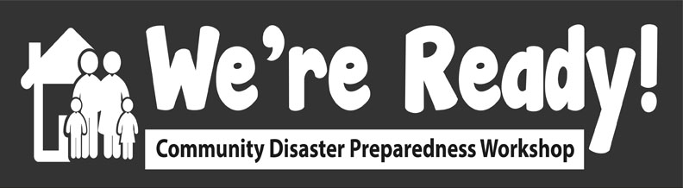

Activity 6: Mock Disaster Simulation Matching Skills/Capacities with Needs
We’re Ready! Workshop May 27, 2021

Role | Needs | Role | Capacities
E.g. 5. Limp Leg | E.g. Assistance walking because lost cane | E.g. 10. Strong | E.g. Carry and lift heavy weights

