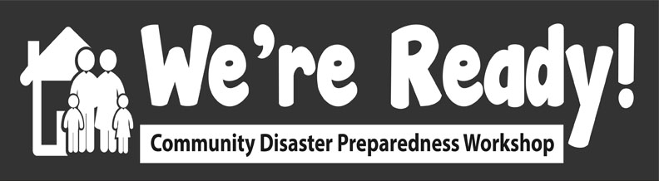
Activity 3: Sharing previous disaster lessons

Session title: Activity 3: Sharing Previous Disaster Experiences and Lessons Learned

Date & time:

This activity will take 30 minutes

Presenter:

Learning objectives:

- Share individual experiences of previous disaster experiences.
- Examine what went well during the response to these disasters.
- Reflect on what could be done better during a disaster.
Description of learning activity:

The objective of this activity is to get people thinking about their previous disaster experiences. Having this in the front of their minds will help in developing the community disaster plan.

The group will answer the following questions:
- What disasters/emergencies have you experienced at home or at work or vacation? (Not including COVID-19)
- What worked well during the response to these disasters?
- What improvements could be made to disaster response?
Face to face option:

When we did this activity face to face, participants were divided into groups seated at 5 tables, each provided with pens and flipchart paper. Each table had an anchor, which was one of the organizers who was stationed at each table in order to facilitate the discussion and capture responses to the questions. If you don’t have enough anchors for each table, then some will have to play this role at more than one table.

Each group shares their responses to the questions which are captured by the anchor on flipchart paper. At the end, each group shares back a summary of responses to the big group.
Online option description: breakout rooms and jam board (and instructions on use)
- We will use breakout rooms (which you will move to shortly) to work through the questions listed above - these will be on the jamboard as well.
- You will have 15 minutes to do the activity
- When you get into breakout rooms you can all introduce yourselves (you will spend a couple activities in the same breakout groups so it’ll be good to get to know each other a little bit!)
- For jamboards, the facilitator in your breakout rooms will write the link to the jamboard in the chat - you will be able to write your own sticky notes on there as you see fit. You can add to the stickynotes by double clicking on one then pressing done (DEMONSTRATE).

HOW TO USE JAMBOARD:
The way to add your ideas is by moving the sticky note off the pile and then double clicking on it and then the format changes and you can type. Note that you can change the colour of the sticky note on the top right hand side. Then after you are done typing your response, click either Save or Cancel. You can also create more Sticky Notes by putting your cursor on a sticky note, then right clicking, and pressing Duplicate.

- We will be using jamboard throughout the day so you will get plenty of experience using this tool in different ways.
- Any questions before we move to breakout rooms?
Breakout rooms activity (15 min) (4 facilitators)
- NOTE: Facilitators, make sure you give everyone a minute or two at the beginning to introduce themselves because they will spend a couple activities together in these same breakout groups.
- Facilitators will help the group to answer the questions above
Each small group will report back to the whole group when we come back to the main zoom room(1-2 min per group) (10 min total)
Questions and reflections: Does anyone have any questions or other ideas about this activity?
Instructional techniques:

Facilitated discussion with key points recorded on jamboard - any participant can add notes to jamboard (facilitators to put link to jamboard in chat once everyone moves to the breakout rooms.

10 minutes: Each group will then share with the entire zoom room one thing that worked and one that did not.
Speaking points:

Use the description of the activity above

Assessment plan:
Notes taken during this activity will be shared with the entire group.

Estimated duration of activity:
2 minutes introduction
18 minutes discussion
10 minutes big group sharing

