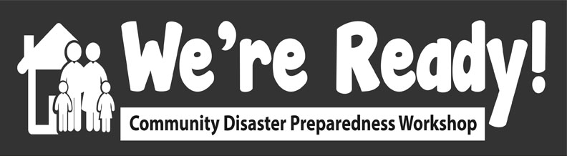
Activity 1: Pre-Workshop Survey
Instructional Plan

Session title: Pre-workshop (Baseline) Survey

Date & time: May 27 9:20 - 9:30 MT (10 min)

Presenter:

Description of learning activity:

Participants complete the survey on mentimeter.com.

Learning objectives:
To evaluate the effectiveness of the workshop in order to assess the success of the We’re Ready! Pilot Project.

Instructional techniques:
- Provide instructions for participants to use Mentimeter
- Ask participants to read the instructions in the survey (including consent) and to fill out survey
Speaking points:

The purpose of the survey is to determine whether the We’re Ready! workshop was effective based on what we set out to do (purpose, goal, etc). Additional information is also gathered to gain a better understanding about participant’s risk awareness, experience with major emergency or disaster, emergency preparedness behaviours, social connections, and confidence in knowing what to do in an emergency. The information you provide is very valuable and will help us improve the workshop in the future. Participating in the survey is voluntary.
The survey is online using Mentimeter. Who has experience using it?
When you are running this workshop in your community as a facilitator, you will need to have your own Mentimeter account and you can just import the existing pre-workshop and post-workshop surveys you will be filling out today - we will send you instructions in the follow-up email to the workshop on (get your own account from https://www.mentimeter.com/login). After your workshop, you can download the results in excel and e-mail the survey results to me at ebogdan@ualberta.ca. In the package we will email you after the workshop there will be more instructions on Mentimeter and the surveys.
You have about 8 minutes to complete the survey and to jot down ideas into the Implementing We’re Ready! in My Community worksheet which you can access at this link: https://docs.google.com/document/d/16NSVB15yqpMFutDeF99xqy-iszVH4JMefopuELGMc9Q/edit?usp=sharing If you have not already done so, please make a copy of it and then use it or download the file in the Chat box. Please wrap up at 9:30 MT so we can start Activity 2.
Completing the survey is optional and responses are anonymous
Go to https://www.menti.com and enter the code _____ [FACILITATOR TO DO AND NOT SAY: enter this into the Chatbox - I can obtain this code when I click on Present in my menti account at https://www.mentimeter.com/login].

For facilitator:
- Open Mentimeter account
- Click on the survey want to run (it will open)
- Click on the blue button ‘Present’ in the top right hand corner
- The survey will open for participants, put into Chatbox the code that is generated at the top of the page

To download the pre-workshop survey:
Pre-Workshop https://www.mentimeter.com/s/acda5e623af90bdda9becf1f858942a2/0864465c2ee6

To download the post-workshop survey:
Post-Workshop
https://www.mentimeter.com/s/32edb98f5930773f13b0b784de709f54/71a9ef4fa238/

If you are not sure about how to answer a question or the wording of a question, don’t hesitate to ask me.
Are there any questions before we get started?
Once completed survey…
Thank you again for taking the time, this information is very valuable to us. Now for some fun activities!
Demo activity details:
See pre-workshop survey for details
Assessment plan:
Pre-workshop and post-workshop survey results will be analyzed. The results will also be used to further improve the We’re Ready! Project.
Estimated duration of activity:
10 minutes
Instructor (I) and participant (P) resources/materials:
I - Timer visible to all participants
I - website link for Mentimeter survey
P - Implementing We’re Ready! in My Community worksheet

Volunteers required (# and specific expertise?):
- 1 primary facilitator who has a Menti account and knows how to navigate it

Facilities required:
Zoom

Additional notes:

