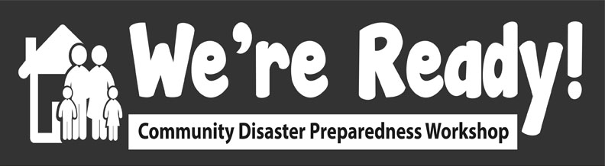

***We’re Ready! Community Disaster***

***Preparedness Workshop***

# *Presented this 21st day of June, 2019*

**NAME GOES HERE**

*This is to acknowledge that*

*Has successfully completed the*